**Introduction**

**Methodology**

**Data Processing**

**Analysis**

There are 26,125 zip codes nationwide, and 58 of them belong to San Antonio, Texas. The DCI percentile for an average zip code in San Antonio is 50.5 with 18% of the population 25 years and older without a high school diploma or equivalent, 8.6% of habitable housing that is unoccupied, excluding properties that are for seasonal, recreational, or occasional use; 30% of the prime-age population (ages 25-64) not currently in work, 18.7% of the population whose household income falls below the poverty line, 103% of its state’s median income, 16.5% change in the number of jobs from 2011 to 2015, and 11.4% change in the number of business establishments from 2011 to 2015.

Located in the West South Central subregion of the South region, San Antonio is among top 31 cities with at least 30 zip codes. It is also similar to 10 cities that have between 35% and 65% Hispanic residents, inclusively, and a population of at least 250,000. Demographically, the average zip code of San Antonio is inhabited by approximately 38% Caucasian, 51% Hispanic, 8% Black, and 2% Asian residents with 2% more from mixed or other races.

The following graph is the breakdown of average DCI percentile by region among Hispanics which demonstrates that the higher percentage of Hispanic Residents there are per zip code, the more distressed the community is:

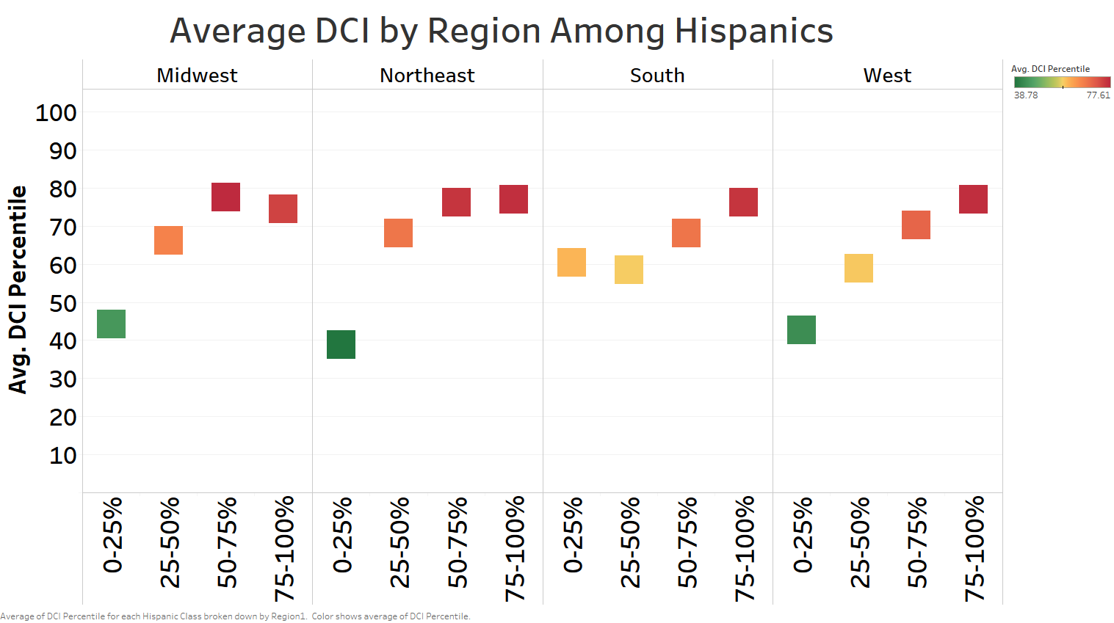

The following graph compares percentage of distressed class among states and Washington, D.C. and the orange dot represents Texas:

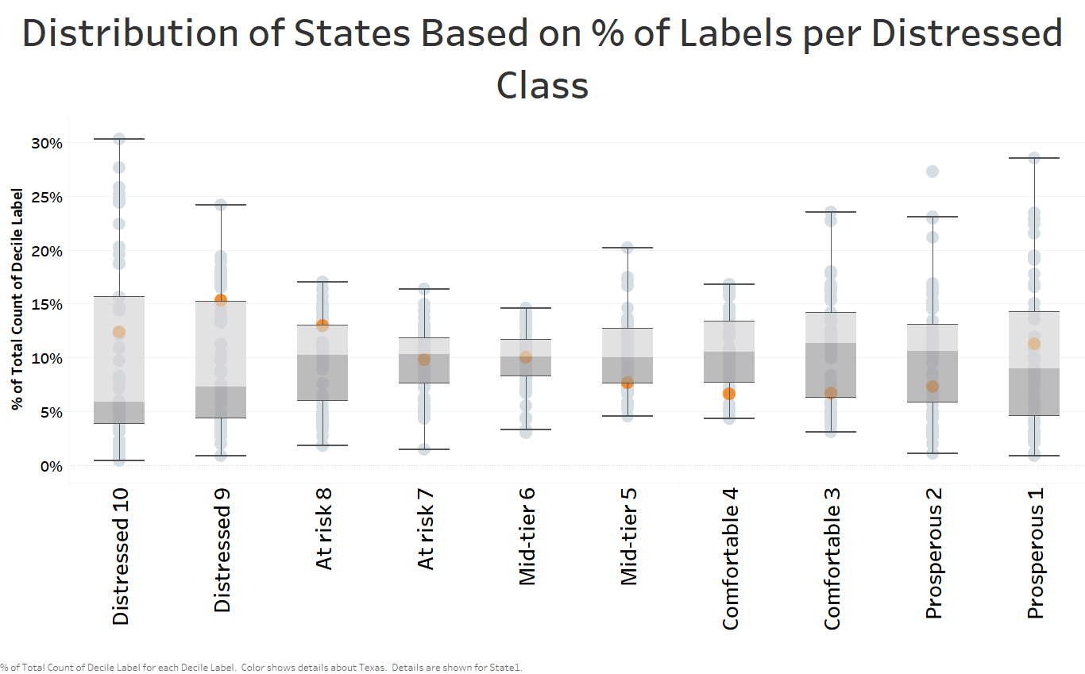

For example, Texas ranks above average in the most distressed class (Distressed 10) with 12.37%. The states with the least and the most number of zip codes in the most distressed class are New Hampshire with 0.45% and Mississippi with 30.28%, respectively.

The following seven graphs show the impact of each variable on the average DCI percentile for each subregion:

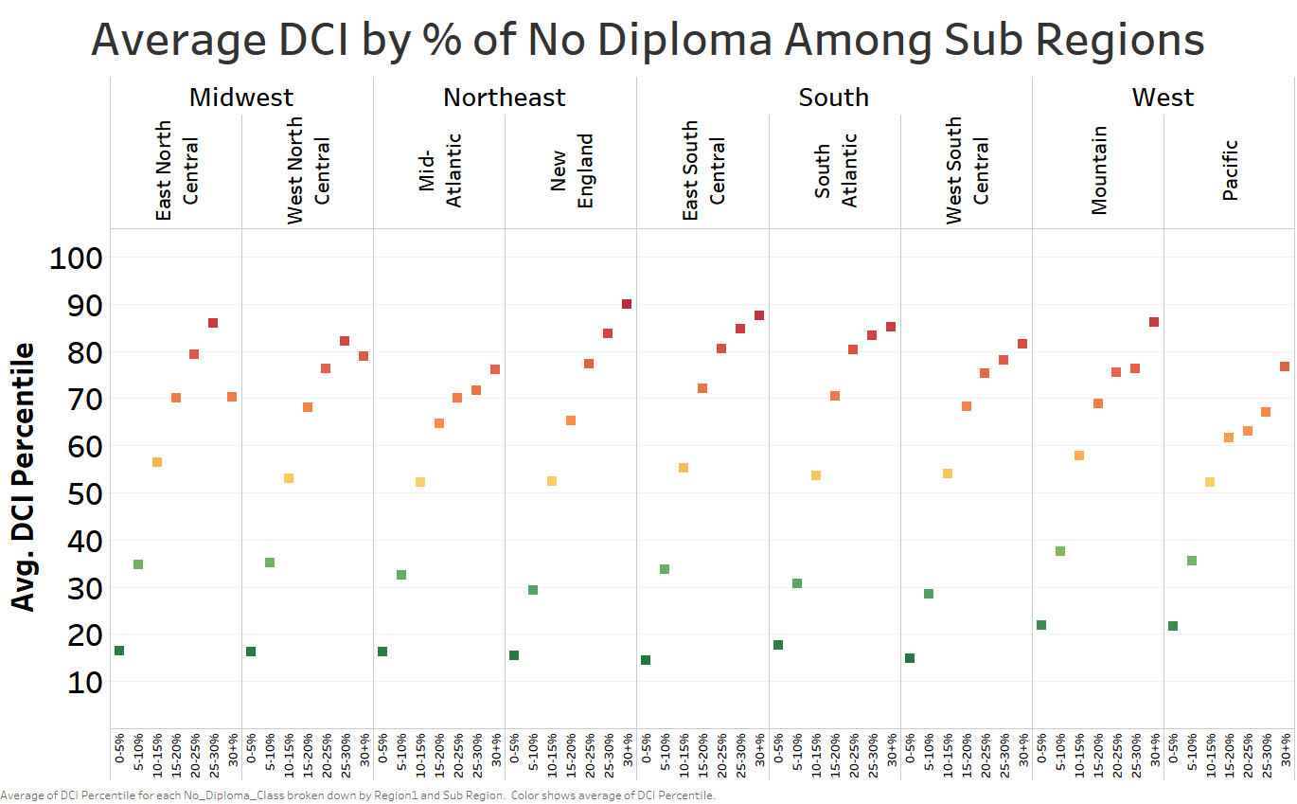

which demonstrates that the higher the percentage of the population 25 years and older without a high school diploma or equivalent, the higher the average DCI percentile is.

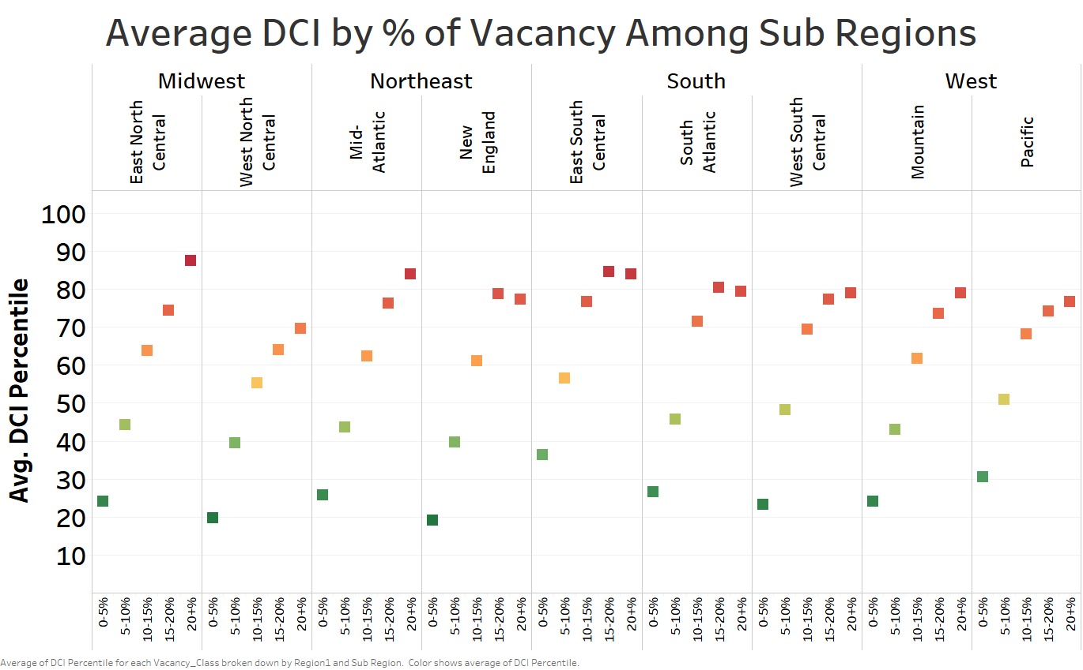

which demonstrates that the higher the percentage of habitable housing that is unoccupied excluding properties that are for seasonal, recreational, or occasional use, the higher the average DCI percentile is.

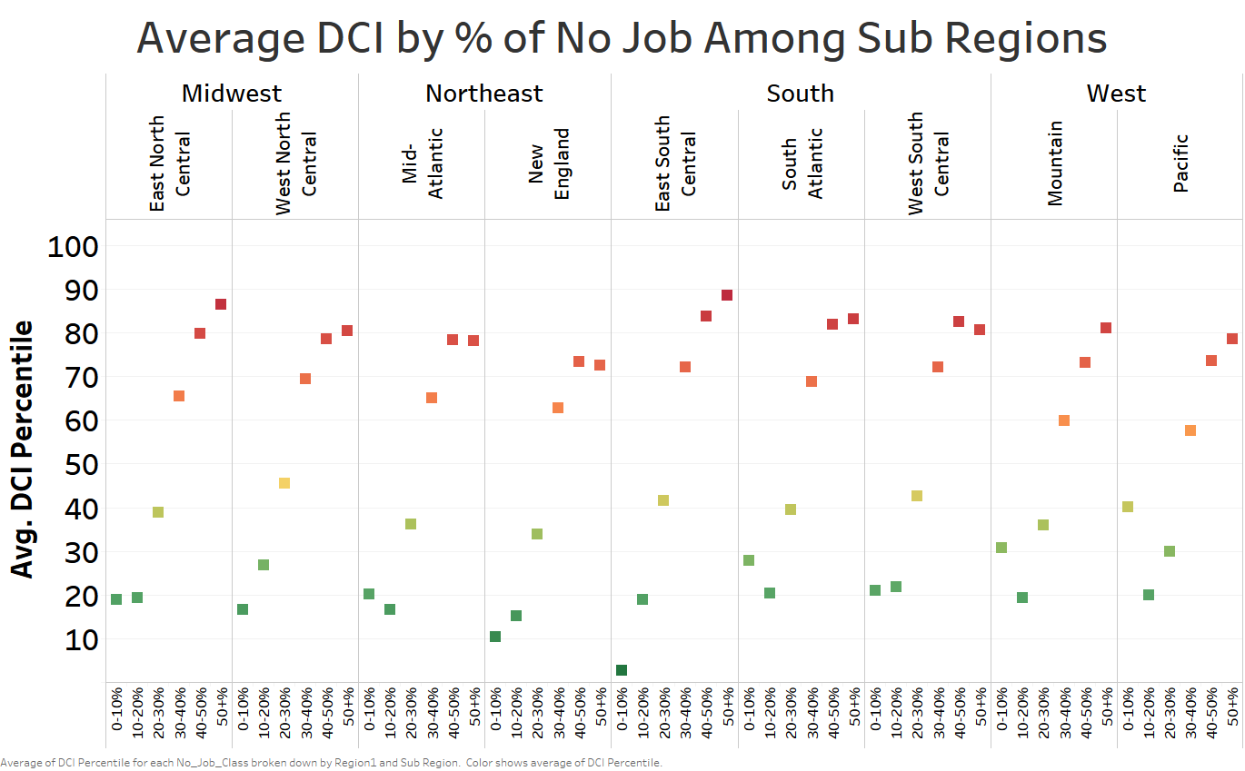

which demonstrates that the higher the percentage of habitable housing that is unoccupied, the higher the DCI percentile is.

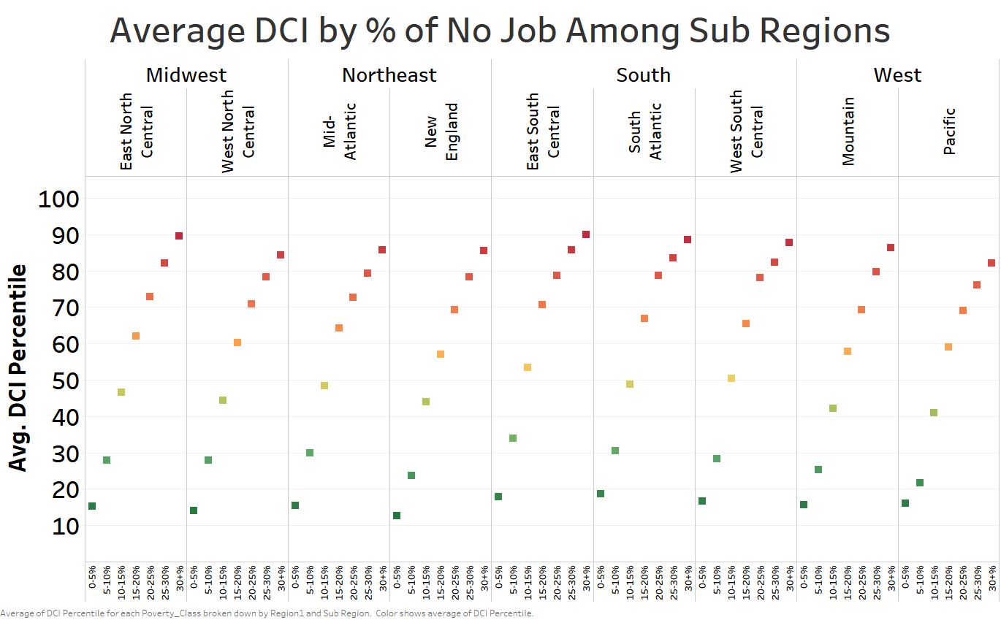

which demonstrates that the higher the percentage of the prime-age population (ages 25-64) not currently in work, the higher the DCI percentile is.

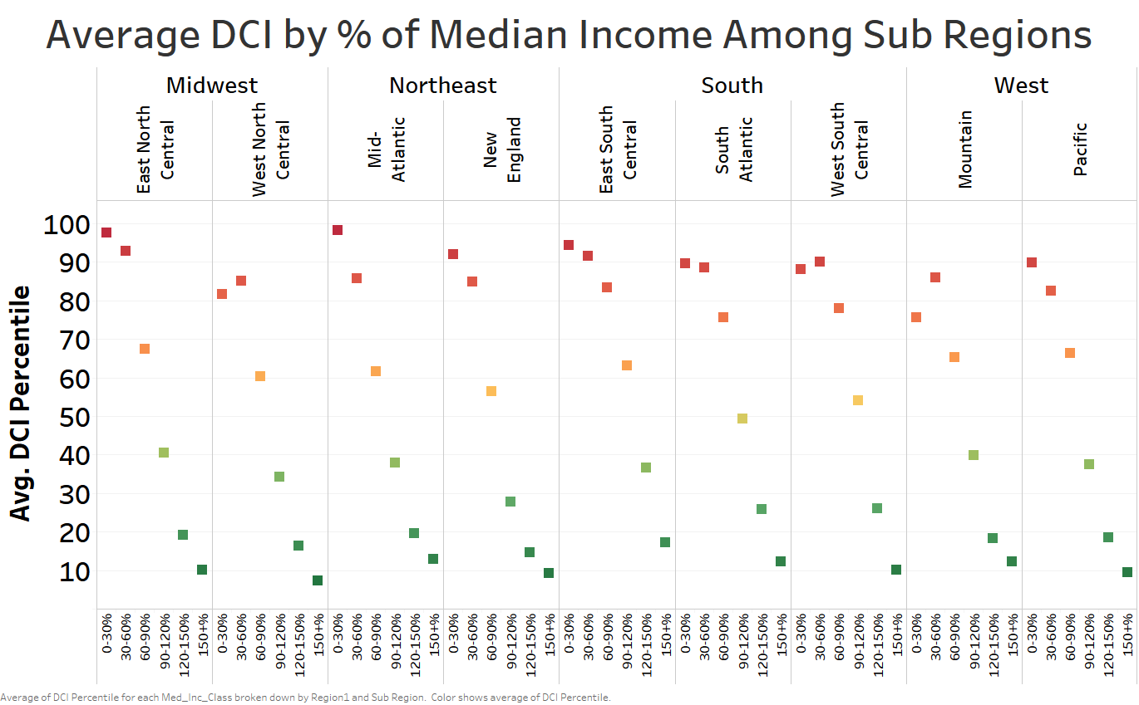

which demonstrates that the higher the percentage of its state’s median income, the lower the DCI percentile is.

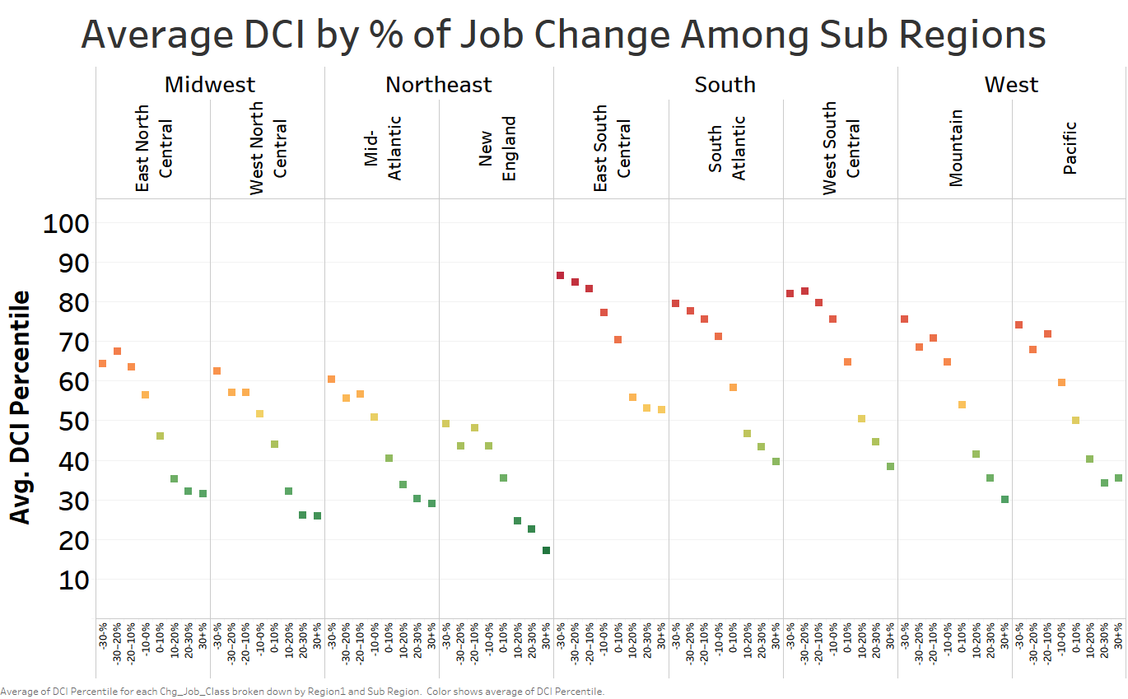

which demonstrates that the higher the percentage of change in the number of jobs from 2011 to 2015, the lower the DCI percentile is.

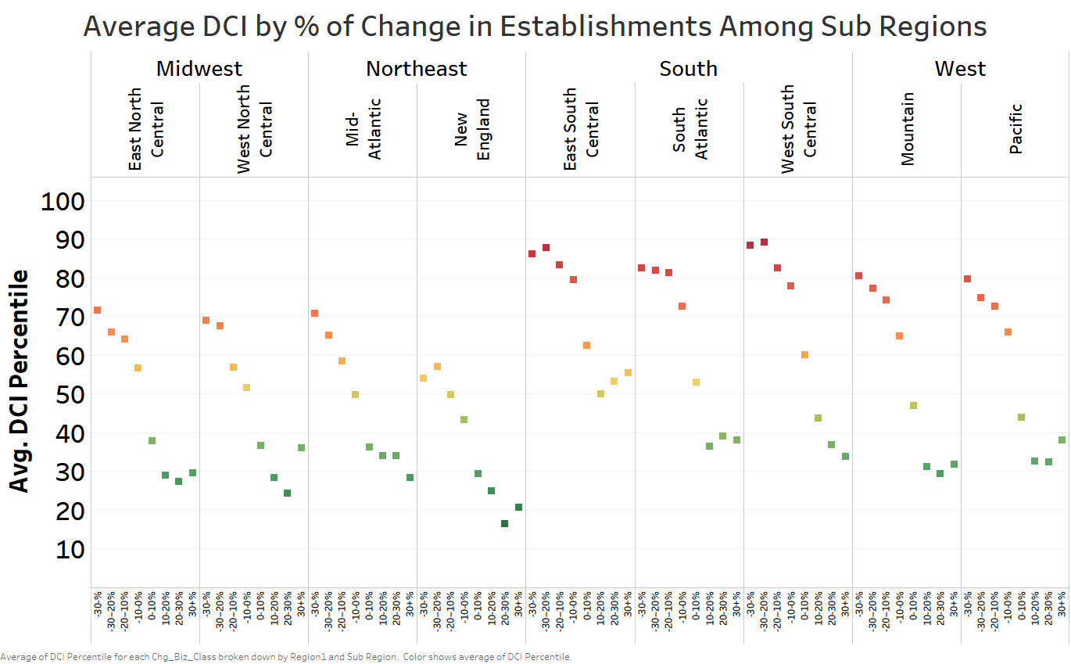

which demonstrates that the higher the percentage of change in the number of business establishments from 2011 to 2015, the lower the DCI percentile is.

By using stepwise multilinear regression (base variables are South region and West South Central subregion) in R, the information shows the amount of significance per variable based on sum of squares to predict average DCI percentile:

Df Sum of Sq RSS AIC

<none> 3458433 127680 🡨**Least significant variable**

+ Mountain 1 14 3458420 127682

+ Pacific 1 14 3458420 127682

+ South_Atlantic 1 5 3458428 127682

- Area_Water 1 686 3459119 127684

- East_South_Central 1 1022 3459455 127686

- Asian 1 1058 3459491 127686

- Chg_Job 1 1469 3459902 127689

- Hispanic 1 1816 3460249 127692

- Population 1 3941 3462374 127708

- East_North_Central 1 5024 3463458 127716

- White 1 7223 3465656 127733

- Area_Land 1 9071 3467504 127747

- Mid_Atlantic 1 10568 3469002 127758

- Mixed_Other 1 12707 3471141 127774

- Northeast 1 17570 3476004 127811

- Midwest 1 24098 3482532 127860

- West 1 26010 3484443 127874

- No_Diploma 1 306199 3764632 129895

- Poverty 1 344973 3803406 130162

- No_Job 1 526756 3985189 131382

- Vacancy 1 693277 4151710 132452

- Med_Inc 1 906837 4365270 133762

- Chg_Biz 1 945668 4404101 133993 🡨**Most significant variable**

The top five most significant variables to predict average DCI percentile are:

1. The percent change in the number of business establishments from 2011 to 2015.
2. The percent of its state’s median income.
3. The percent of habitable housing that is unoccupied, excluding properties that are for seasonal, recreational, or occasional use.
4. The percent of the prime-age population (ages 25-64) not currently in work.
5. The percent of the population whose household income falls below the poverty line.

Hence, these are the five out of seven main variables that make up the average DCI percentile. The percent of the population 25 years and older without a high school diploma or equivalent is ranked 6th most significant variable while the percent change in the number of jobs from 2011 to 2015 is ranked 17th most significant variable. The variables in the multilinear equation explain 84.1% of the variance in average DCI percentile:

Residual standard error: 11.51 on 26104 degrees of freedom

Multiple R-squared: 0.8411, Adjusted R-squared: 0.841

F-statistic: 6911 on 20 and 26104 DF, p-value: < 2.2e-16

Looking at the following coefficients, if a resident lives in a zip code in the Northeast region compared to the South region, the average DCI percentile drops by 3.902. Similarly, for every one unit increase in percentage change in the number of business establishments from 2011 to 2015, the average DCI percentile drops by 0.02632.

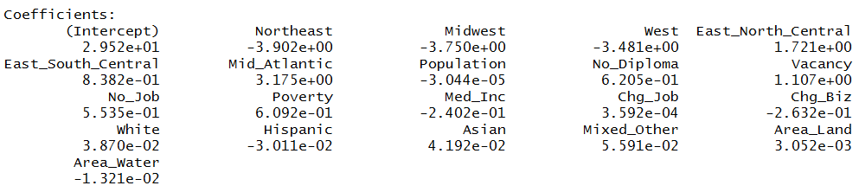

The average DCI percentile is mapped among different zip codes in San Antonio as shown below where dark green indicates very high prosperity and dark red indicates very high distress:

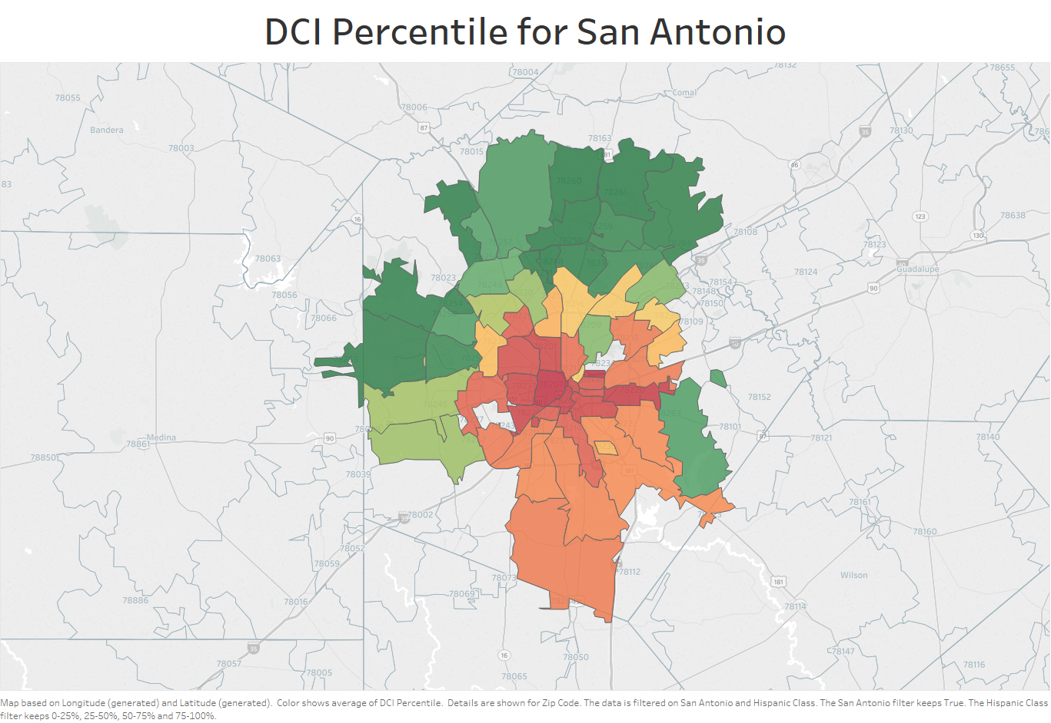

The following maps of San Antonio are based on seven main variables that comprise the average DCI percentile:

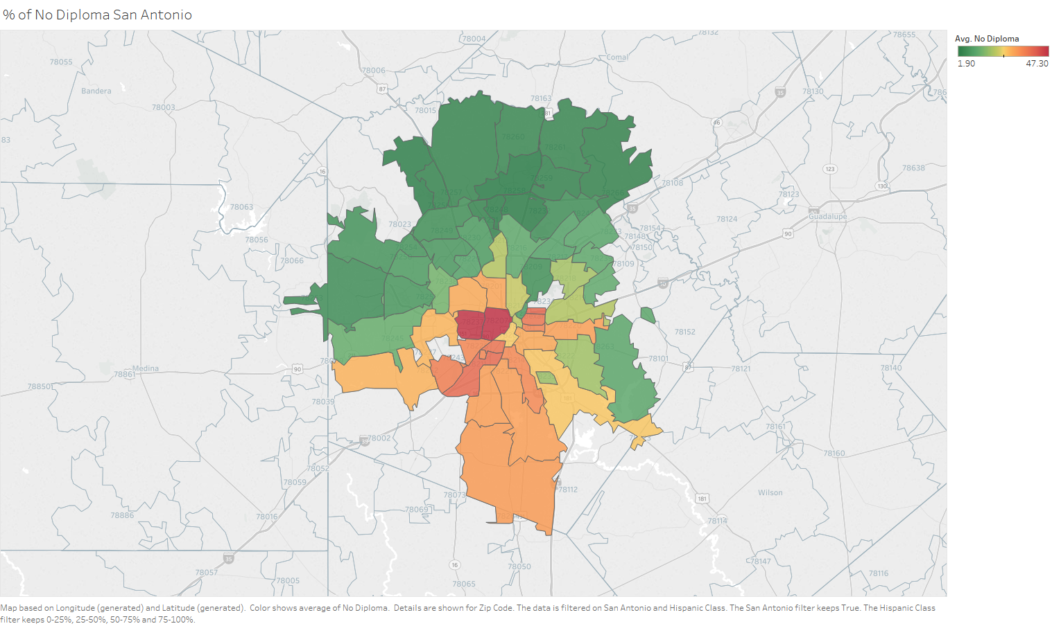

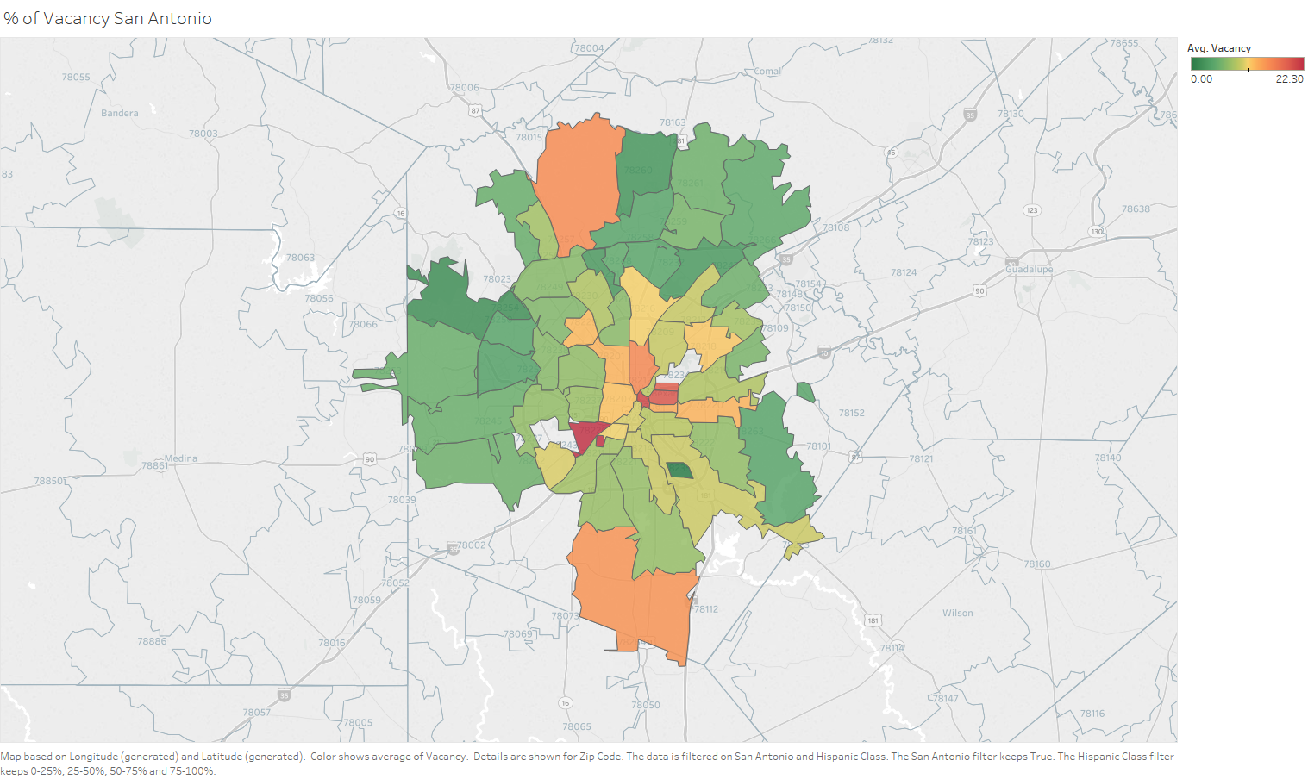

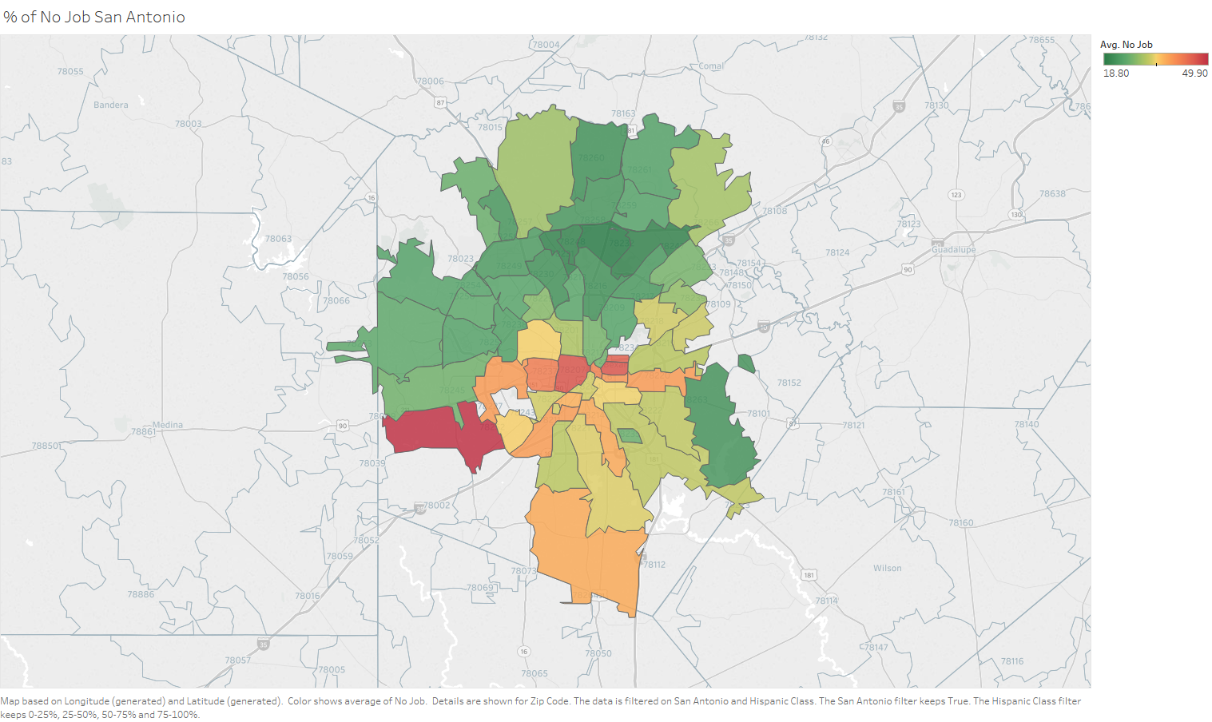

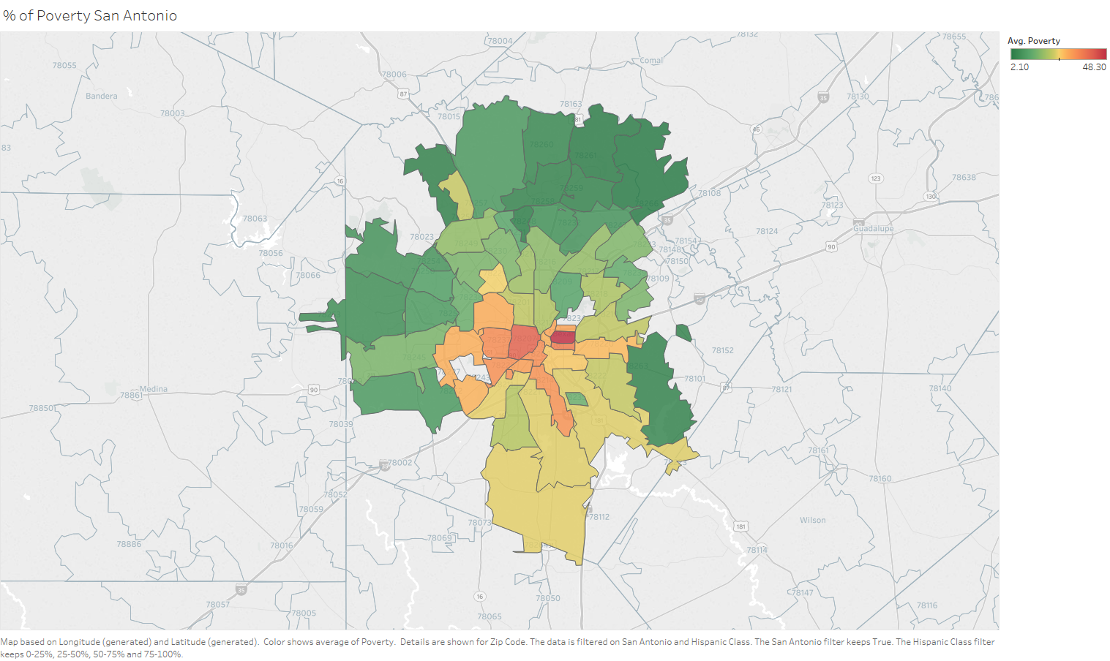

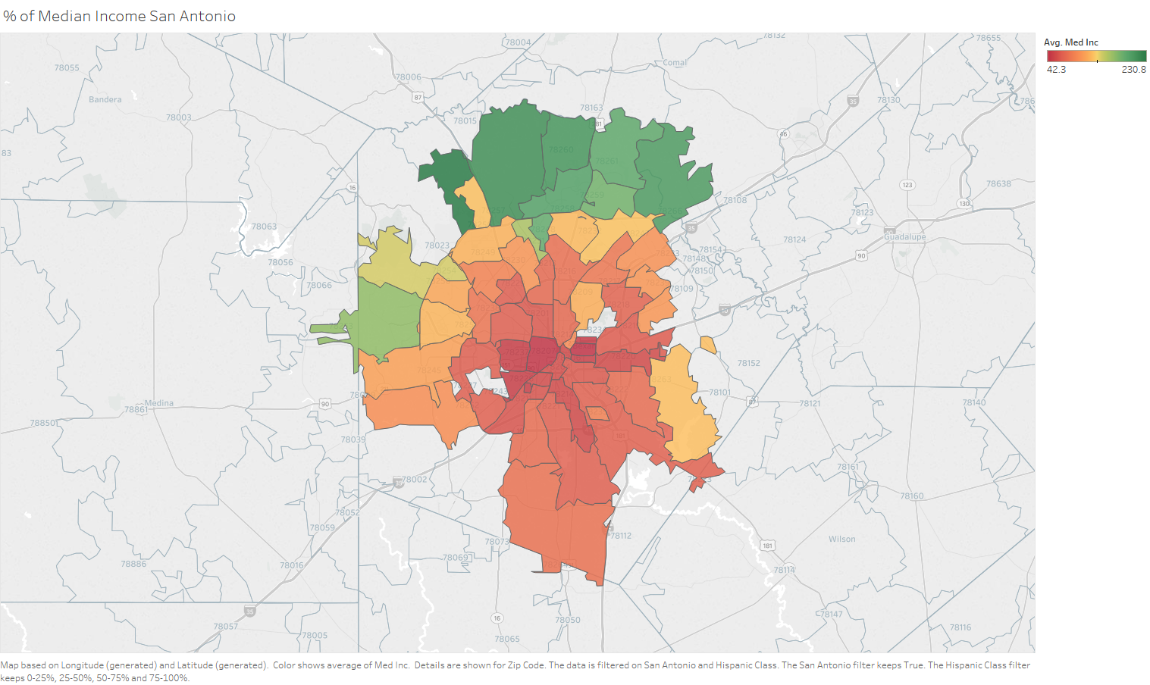

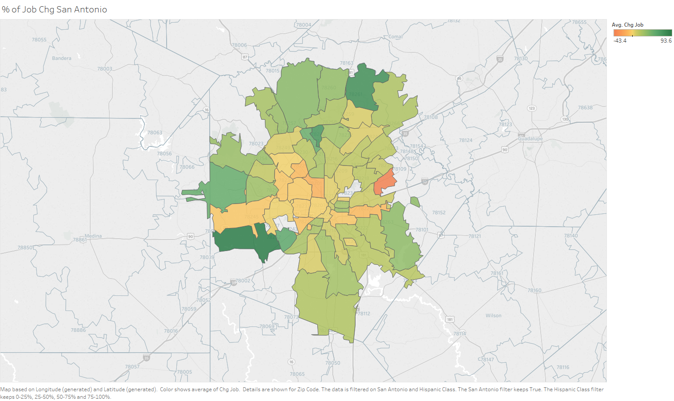

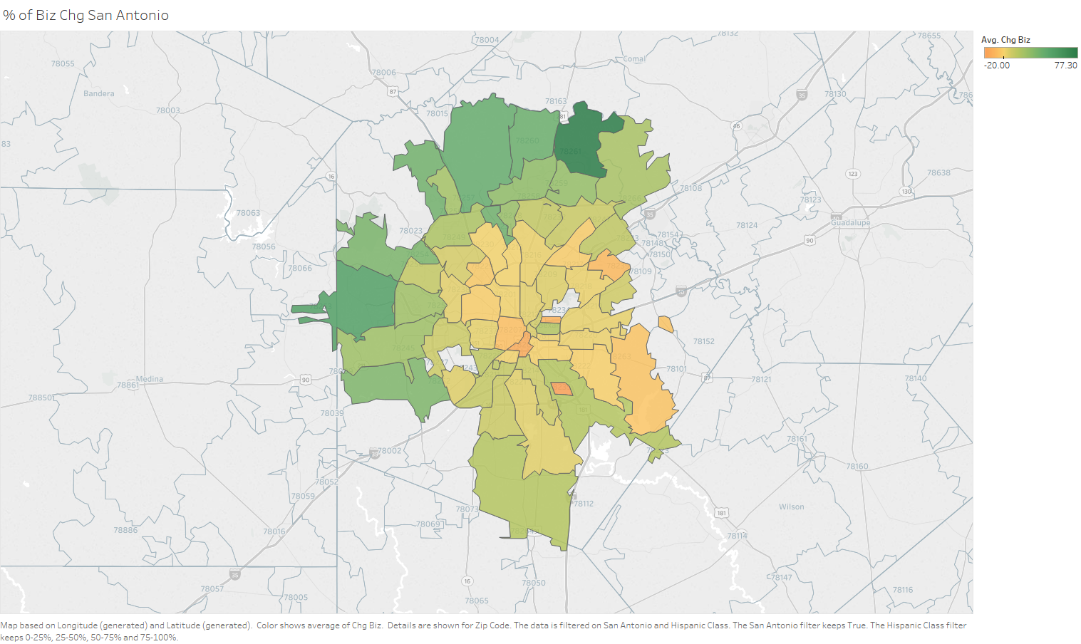

Among top 31 cities with at least 30 zip codes, San Antonio ranks 14th worst in average DCI percentile, 8th worst in percent of the population 25 years and older without a high school diploma or equivalent, 13th best in percent of habitable housing that is unoccupied excluding properties that are for seasonal, recreational, or occasional use; 7th worst in percent of the prime-age population (ages 25-64) not currently in work, 15th best in percent of the population whose household income falls below the poverty line, 16th best in percent of its state’s median income, 8th best in percent of change in the number of jobs from 2011 to 2015, and 8th best in percent of change in the number of business establishments from 2011 to 2015.

San Antonio is among eleven cities in the nation with between 35% and 65% Hispanic residents, inclusively, and a population of at least 250,000. The other ten are: Albuquerque, NM; Anaheim, CA; Bronx, NY; Chula Vista, CA; Corpus Christi, TX; Fresno, CA; Houston, TX; Los Angeles, CA; Miami, FL; and Riverside, CA. San Antonio ranks 5th best in average DCI percentile, 3rd best in percent of the population 25 years and older without a high school diploma or equivalent, 3rd worst in percent of habitable housing that is unoccupied excluding properties that are for seasonal, recreational, or occasional use; 5th best in percent of the prime-age population (ages 25-64) not currently in work, 4th best in percent of the population whose household income falls below the poverty line, 5th best in percent of its state’s median income, 6th best in percent of change in the number of jobs from 2011 to 2015, and 3rd best in percent of change in the number of business establishments from 2011 to 2015.

**Considerations and Caveats**

The demographic data which was collected from two websites, [www.zipwho.com](http://www.zipwho.com) and <https://statisticalatlas.com/>, may not be accurate, so a suggestion to remedy the problem is to purchase a subscription from <https://www.zip-codes.com/zip-code-database.asp> which contains up-to-date information for each zip code in the United States. At least five datasets to be merged with the current dataset that would be helpful for further analysis are: health, crime, education, incarceration rate, and prison expenditures (https://www.justicemapping.org/).

**Conclusion**

**References**